A picture containing clipart

Description generated with very high confidence

Hands-on

Installing Jenkins

DevOps Training

[**support@intellipaat.com**](mailto:support@intellipaat.com)

**+91-7022374614**

**US: 1-800-216-8930(Toll Free)**

JENKINS INSTALLATION

**We need to launch an instance of t2.micro with a security group of all traffic and source anywhere.**

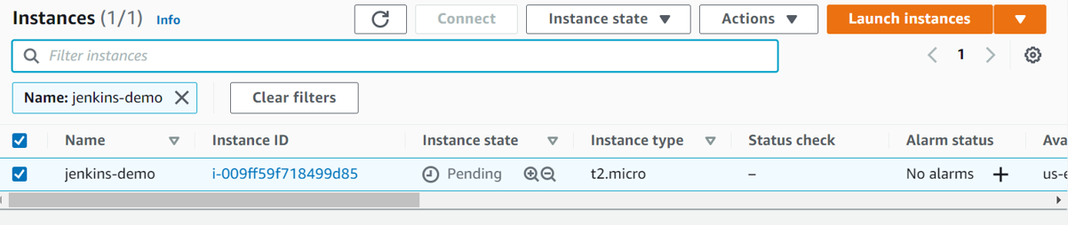

# Use the following commands for installing Jenkins.

**sudo apt-get update**

**sudo apt install ca-certificates**

**sudo apt-get install openjdk-11-jdk -y**

**wget -q -O - https://pkg.jenkins.io/debian-stable/jenkins.io.key | sudo apt-key add -**

**sudo sh -c 'echo deb https://pkg.jenkins.io/debian-stable binary/ > /etc/apt/sources.list.d/jenkins.list'**

**sudo apt-get update**

**sudo apt-get install jenkins -y**

# Step 1: Create a script file and paste the following commands into the file.

**sudo nano jenkins.sh**

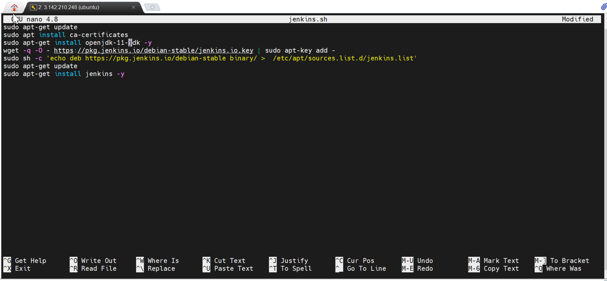

# Step 2: Run the script file using the following command.

**bash <file name>**

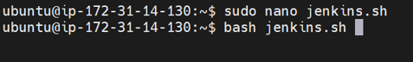

# Step 3: To check the service of Jenkins use the following command.

**service jenkins status**

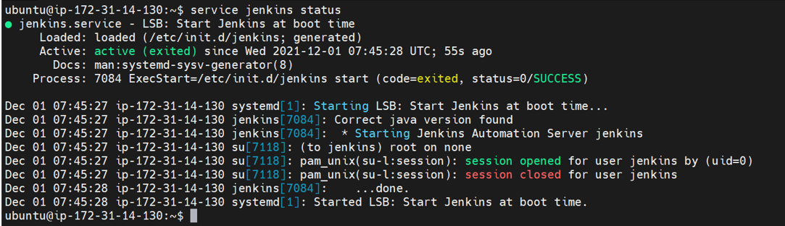

**Step 4: Copy the public IP of the instance and paste it with :8080 in the browser.**

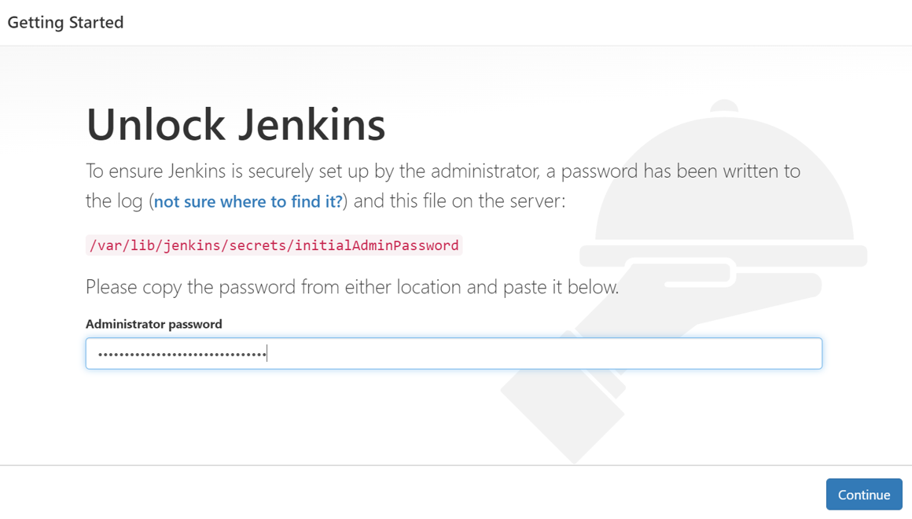

**Step 5: Copy the path and paste it into the terminal with sudo cat.**



**Step 6: Paste the password in the Jenkins admin password to sign in to Jenkins.**

**Step 7: Select the option: Install Suggested Plugins**

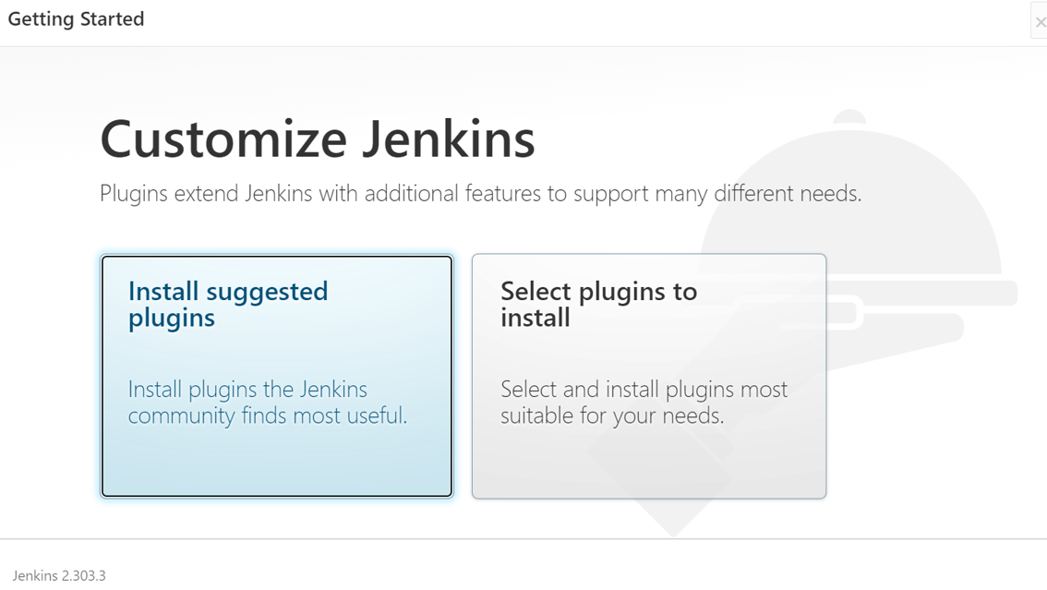

**Step 8: Create admin credentials for Jenkins.**

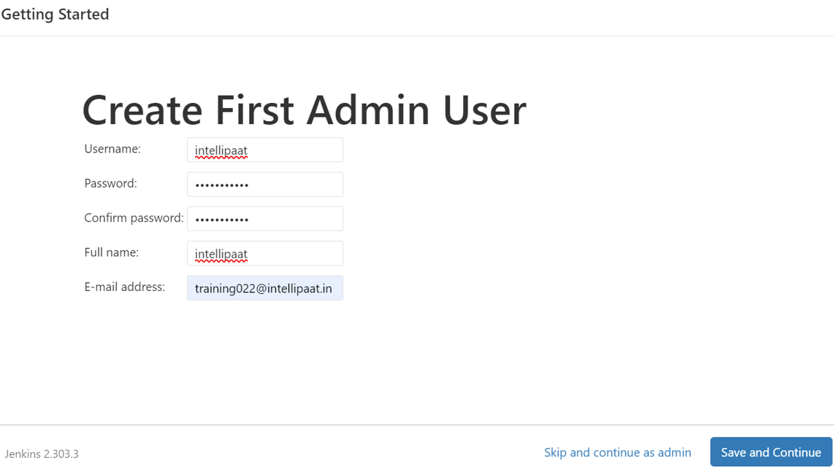

**Step 9: Select the save and finish option to login into the Jenkins dashboard.**

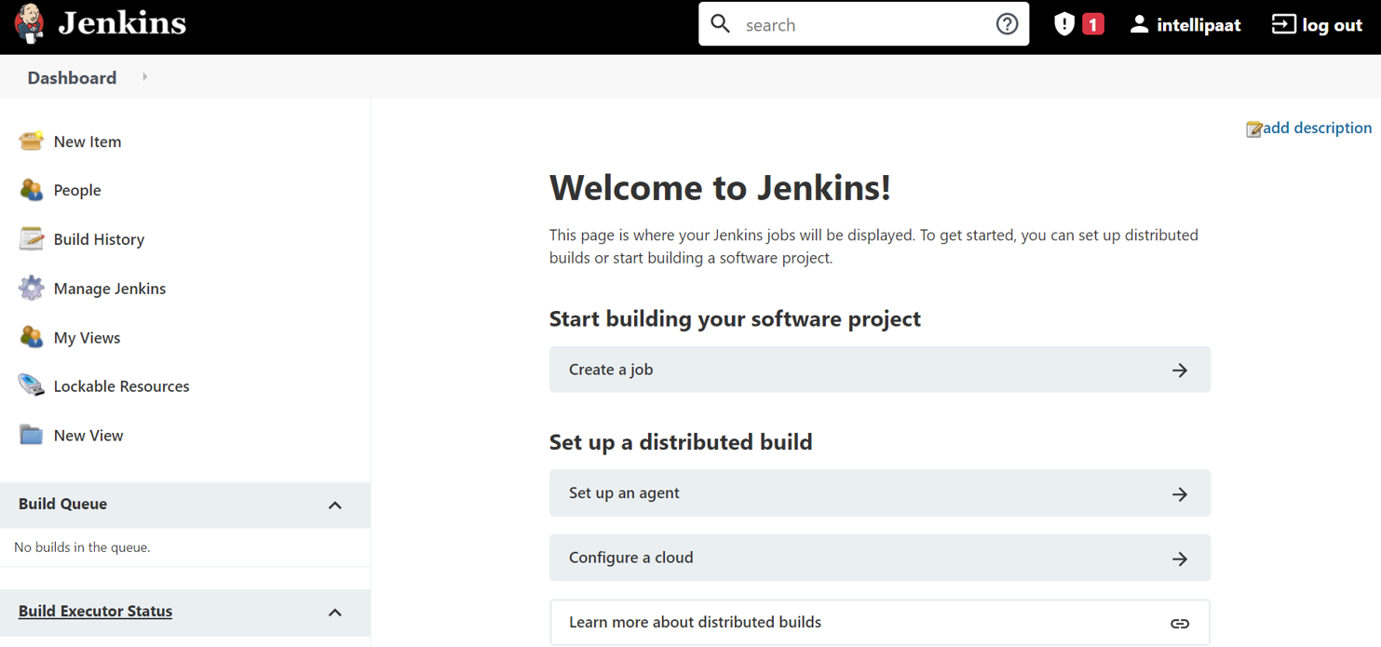

Adding jenkins nodes or slaves:

<https://www.youtube.com/watch?v=V2ejGOY_uJI>